1) Key languages your company handles the most: Checkbox
Response: This is Done
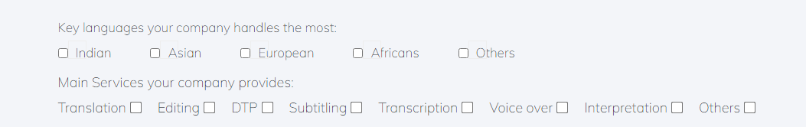
2) Text Area Not mandatory
Response: This is Done

3) Euro Dollor Inr Pound Dropdown
Response: This is Done

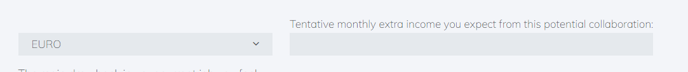
4) The main drawback in your current job you feel: Change Text
Response: This is Done
5) Tentative monthly extra income you expect from this potential collaboration :Add Potential
Response: This is Done

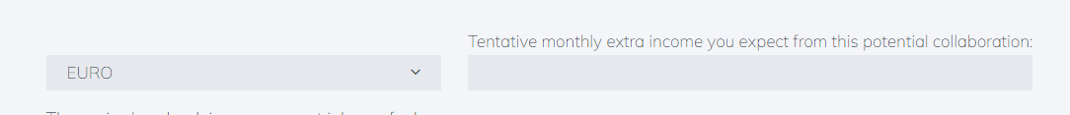
6) FreeLancer Registration
Response: This is Done
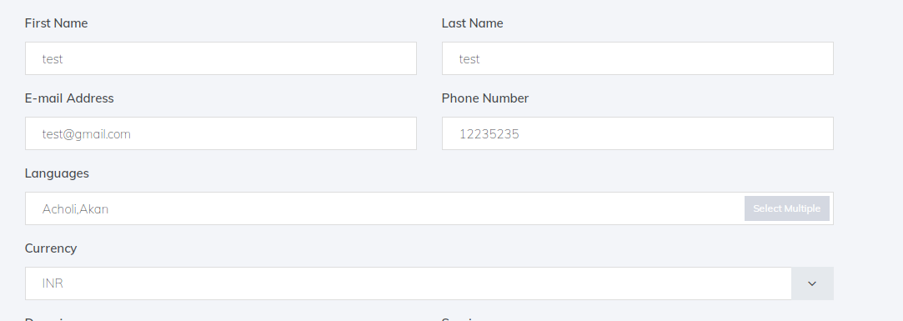

7) Plugin Update
Response: This is Done

8) Plugin Automatic Update
Response: This is Done

9) User Count
Response: This is Pending

10) Order Transation Highlight Button
Response: This is Done

11) Cat Tools MultiSelected
Response: This is Done
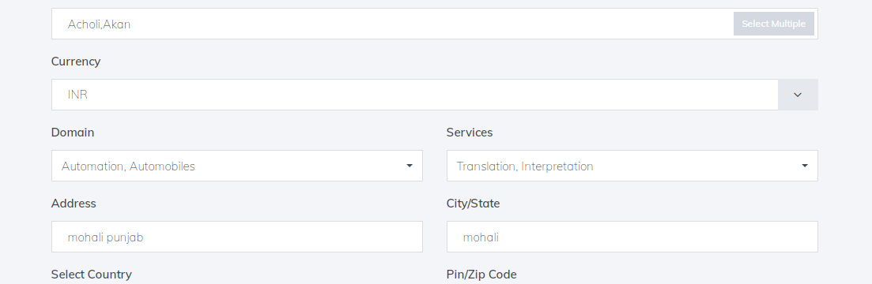

12) Add Order Email Address Remove
Response: This is Done

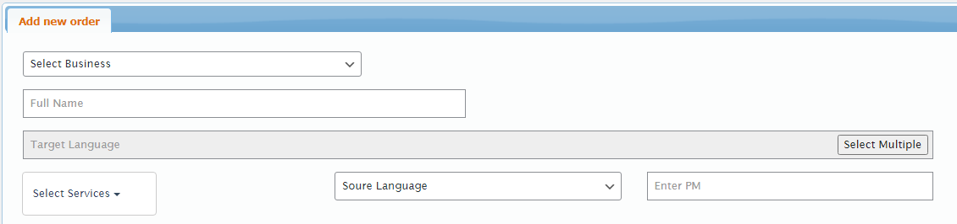

13) Select Services After Target Language
Response: This is Done

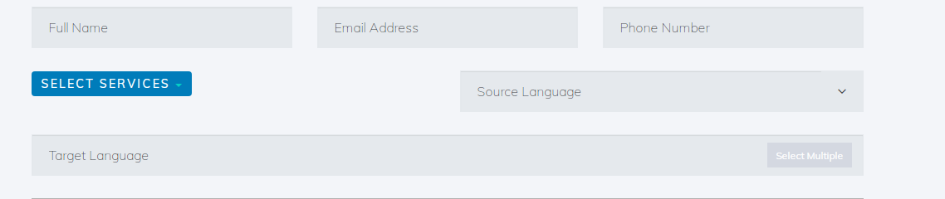

14) User name Remove From Users
Response: This is Pending

